List of Urdu Articles

Urdu Columns
Year 2019

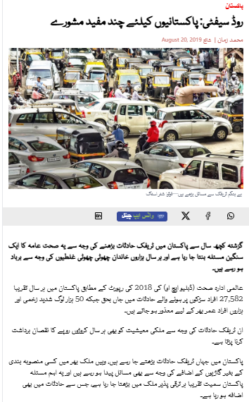
Newspaper: Dawn News
Link:
https://www.dawnnews.tv/news/1109056/
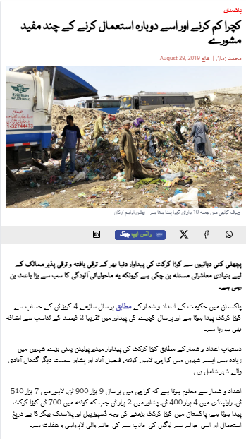
Newspaper: Dawn News
Link:
https://www.dawnnews.tv/news/1109669/
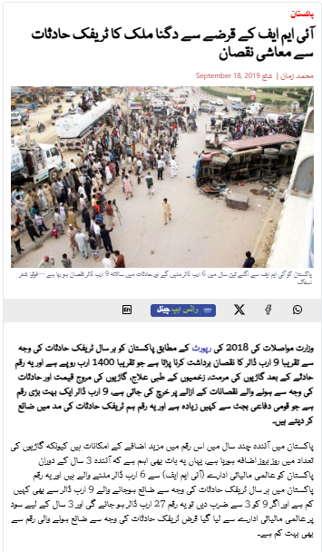
Newspaper: Dawn News
Link:
https://www.dawnnews.tv/news/1110827/

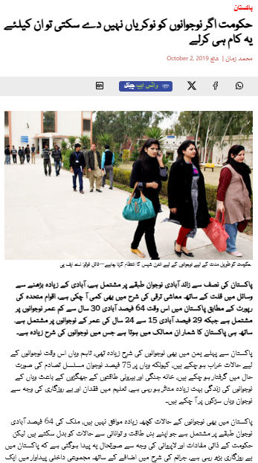
Newspaper: Dawn News
Link: https://www.dawnnews.tv/news/1111619/

Year 2024
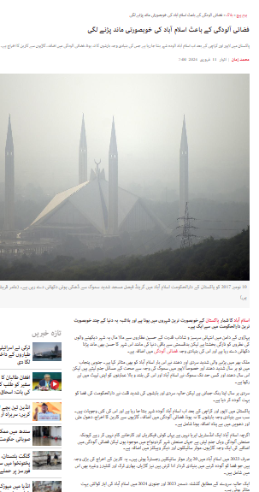
Newspaper: Independent Urdu
Link:
https://www.independenturdu.com/node/160301

Year 2024
Columns Published on 92 Newspaper
